Selenium Assignment 03 – Keyboard Actions

Keyboard Actions
As introduced in Table 3-3, two main methods in WebDriver objects allow impersonating keyboard user actions: sendKeys() and clear(). Example 3-17 shows a test using these methods.
Example 3-17. Test impersonating keyboard events
@Test
void testSendKeys() {
driver.get("https://bonigarcia.dev/selenium-webdriver-java/web-form.html");

WebElement inputText = driver.findElement(By.name("my-text"));
String textValue = "Hello World!";
inputText.sendKeys(textValue);
assertThat(inputText.getAttribute("value")).isEqualTo(textValue);

inputText.clear();
assertThat(inputText.getAttribute("value")).isEmpty();
}

We use the practice web form to locate the input text named my-text.
We simulate a keyboard typing on it using the method sendKeys().
We assess the input value is as expected.
We reset its content using clear().
We assess the input value is empty.

MANUAL WAIT IN TEST TEARDOWN
If you inspect the complete code of some tests in the repository example, you will discover a pause in the teardown method using Thread.sleep(). As explained in “Waiting Strategies”, this type of wait is usually considered a bad smell (i.e., a characteristic in the source code that can lead to undesirable effects). Nevertheless, I have taken the liberty of using it in some examples for instructional purposes, i.e., to ease the manual inspection of the browser when executing the test locally. I recommend dropping these lines if you plan to reuse the examples in an actual test suite.

File Uploading
There are several use cases in which we will need to impersonate keyboard actions when interacting with web pages through Selenium WebDriver. The first one is file uploading. The standard mechanism to upload files for web applications is using <input> elements with type="file". For instance, the practice web form contains one of these elements:
<input class="form-control" type="file" name="my-file">
The Selenium WebDriver API does not provide a mechanism to handle file inputs. Instead, we should treat input elements for uploading files as regular text inputs, so we need to simulate the user typing them. In particular, we need to type the absolute file path to be uploaded. Example 3-18 illustrates how.
Example 3-18. Test uploading a file
@Test
void testUploadFile() throws IOException {
String initUrl = "https://bonigarcia.dev/selenium-webdriver-java/web-form.html";
driver.get(initUrl);

WebElement inputFile = driver.findElement(By.name("my-file"));
Path tempFile = Files.createTempFile("tempfiles", ".tmp");
String filename = tempFile.toAbsolutePath().toString();
log.debug("Using temporal file {} in file uploading", filename);
inputFile.sendKeys(filename);

driver.findElement(By.tagName("form")).submit();
assertThat(driver.getCurrentUrl()).isNotEqualTo(initUrl);
}

We locate the input field using a by-name strategy.
We create a temporal file using standard Java.
We type its absolute path to the input field.
We submit the form.
We verify that the resulting page (defined in action form attribute) is different from the initial web page.
TIP
The file path sent to the input file should correspond to an existing archive in the machine running the test. Otherwise, the test fails with an InvalidArgumentException exception. See “WebDriver Exceptions” in Chapter 5 for further details about exceptions.
When uploading a file to a remote browser (as explained in Chapter 6), we need to load the file from the local file system explicitly. The following line shows how to specify a local file detector.
((RemoteWebDriver) driver).setFileDetector(new LocalFileDetector());

Range Sliders
A similar situation happens with <input type="range"> form fields. These elements allow users to select a number in a range using a graphical slider. You can find an example in the practice web form:
<input type="range" class="form-range" name="my-range" min="0" max="10" step="1" value="5">
Again, the Selenium WebDriver API does not provide any particular utility to handle these fields. We can interact with them by impersonating keyboard actions with Selenium WebDriver. Example 3-19 shows a test interaction with these fields.
Example 3-19. Test selecting a number with a form slider
@Test
void testSlider() {
driver.get("https://bonigarcia.dev/selenium-webdriver-java/web-form.html");

WebElement slider = driver.findElement(By.name("my-range"));
String initValue = slider.getAttribute("value");
log.debug("The initial value of the slider is {}", initValue);

for (int i = 0; i < 5; i++) {
slider.sendKeys(Keys.ARROW_RIGHT);
}

String endValue = slider.getAttribute("value");
log.debug("The final value of the slider is {}", endValue);
assertThat(initValue).isNotEqualTo(endValue);
}
We send a keyboard key to the range field available in the practice web form. We use the class Keys available in the Selenium WebDriver API to handle special keyboard characters. In particular, we send the right arrow key to the slider, and as a result, it moves to the right (i.e., it increases the selected number within the range).
We assert the resulting selected value is different from the one in the original position.

Mouse Actions
In addition to the keyboard, the other primary input device for interacting with web applications is the computer mouse. First of all, the single-click (also known as left-click or simply click) is impersonated by the Selenium WebDriver API using the method click(), which is one of the methods available per WebElement in Selenium WebDriver. This section shows examples of two typical use cases using this feature: web navigation and interaction with checkboxes and radio buttons in web forms.
Other common mouse actions are right-clicking (also known as context-click), double-clicking, cursor movement, drag and drop, or mouseover. Selenium WebDriver allows impersonating these actions using a helper class called Actions. See the next section for further details. Finally, scrolling is possible in WebDriver by executing JavaScript. I explain this feature in “Executing JavaScript”.

Web Navigation
Example 3-20 shows a test implementing automated web navigation with Selenium WebDriver. This test locates links using XPath and clicks on them, invoking the method click(). In the end, it reads the text content of the web page body and verifies it contains an expected string.
Example 3-20. Test navigating by clicking on links
@Test
void testNavigation() {
driver.get("https://bonigarcia.dev/selenium-webdriver-java/");

driver.findElement(By.xpath("//a[text()='Navigation']")).click();
driver.findElement(By.xpath("//a[text()='Next']")).click();
driver.findElement(By.xpath("//a[text()='3']")).click();
driver.findElement(By.xpath("//a[text()='2']")).click();
driver.findElement(By.xpath("//a[text()='Previous']")).click();

String bodyText = driver.findElement(By.tagName("body")).getText();
assertThat(bodyText).contains("Lorem ipsum");
}

Checkboxes and Radio Buttons
Example 3-21 shows another basic use of the click() method for manipulating checkboxes and radio buttons. To verify the expected state of these elements after the click action, we use an assertion based on the result of the isSelected() method.
Example 3-21. Test interacting with checkboxes and radio buttons
@Test
void testNavigation() {
driver.get("https://bonigarcia.dev/selenium-webdriver-java/web-form.html");

WebElement checkbox2 = driver.findElement(By.id("my-checkbox-2"));
checkbox2.click();
assertThat(checkbox2.isSelected()).isTrue();

WebElement radio2 = driver.findElement(By.id("my-radio-2"));
radio2.click();
assertThat(radio2.isSelected()).isTrue();
}

User Gestures
Selenium WebDriver provides the class Actions, a powerful asset to automate different user actions, both for keyboard and mouse. This class follows the builder pattern. This way, you can chain several methods (i.e., different actions) and perform all of them at the end by calling build(). Table 3-11 summarizes the public methods available in this class. We review these methods through examples in the following subsections.
Method | Description
keyDown(CharSequence key)  keyDown(WebElement target, CharSequence key) | Send a single key (it could be a special character using the class Keys) in the current position (or a given element). The key remains pressed until calling to keyUp().
keyUp(CharSequence key)  keyUp(WebElement target, CharSequence key) | Release a key previously pressed with keyDown().
sendKeys(CharSequence... keys)  sendKeys(WebElement target, CharSequence... keys) | Send a key sequence in the current position (or a given element). This method is different from WebElement#sendKeys(CharSequence...) in two ways: 1) Modifier keys (e.g., Keys.CONTROL, Keys.SHIFT) are not released explicitly. 2) There is no refocus on the element, so Keys.TAB should work.
clickAndHold()  clickAndHold(WebElement target) | Click without releasing the current position (or the middle of a given element).
release()  release(WebElement target) | Release the left-click mouse button previously pressed with clickAndHold().
click()  click(WebElement target) | Click on the current position (or a given element).
doubleClick()  doubleClick(WebElement target) | Double-click on the current position (or element).
contextClick()  contextClick(WebElement target) | Right-click on the current position (or element).
moveToElement(WebElement target)  moveToElement(WebElement target,  int xOffset, int yOffset) | Move mouse cursor to the middle (or shifted to a given offset) of a given element.
moveByOffset(int xOffset,  int yOffset) | Move the mouse from its current position (0,0 by default) by the given offset.
dragAndDrop(WebElement source,  WebElement target)  dragAndDropBy(WebElement source,  int xOffset, int yOffset)  dragAndDropBy(WebElement source,  int xOffset, int yOffset) | This action consists of three steps: 1) Click and hold at the middle (or shifted by a given offset) of the source element location. 2) Move the mouse to the target element location. 3) Release the mouse click.
pause(long pause)  pause(Duration duration) | Perform a pause in the actions chain (in milliseconds or using a Java Duration).
build() | Generate a composite action containing all previous actions.
perform() | Execute the composite action.
Table 3-11. Actions methods

Right-Click and Double-Click
You can find a demo page using three dropdown menus on the practice site (see Figure 3-8). On this page, the first dropdown menu appears when clicking on its button, the second one uses the right-click, and the third one requires a double-click. Example 3-22 shows a test using this page to impersonate user gestures through the WebDriver class Actions.
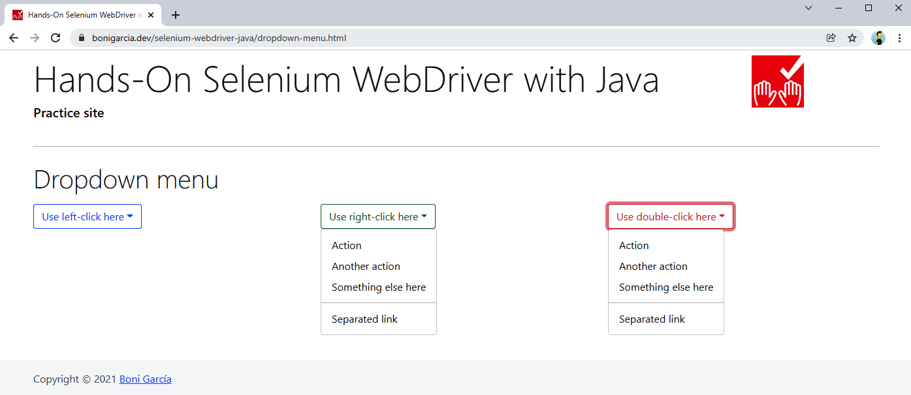
Figure 3-8. Practice web page with dropdown menus

Example 3-22. Test using context and double-click
@Test
void testContextAndDoubleClick() {
driver.get("https://bonigarcia.dev/selenium-webdriver-java/dropdown-menu.html");
Actions actions = new Actions(driver);

WebElement dropdown2 = driver.findElement(By.id("my-dropdown-2"));
actions.contextClick(dropdown2).build().perform();
WebElement contextMenu2 = driver.findElement(By.id("context-menu-2"));
assertThat(contextMenu2.isDisplayed()).isTrue();

WebElement dropdown3 = driver.findElement(By.id("my-dropdown-3"));
actions.doubleClick(dropdown3).build().perform();
WebElement contextMenu3 = driver.findElement(By.id("context-menu-3"));
assertThat(contextMenu3.isDisplayed()).isTrue();
}

We use contextClick() in the middle dropdown menu.
We verify the middle menu is correctly displayed.
We use doubleClick() in the right dropdown menu.
We verify the right menu is correctly displayed.

Mouseover
The second example handling Actions uses a sample web page implementing a mouseover. This page displays four images. Each one shows a text label below the image when the mouse pointer is over. Example 3-23 contains a test that uses this page. Figure 3-9 shows this page when the mouse is over the first picture.

Example 3-23. Test using mouseover
@Test
void testMouseOver() {
driver.get("https://bonigarcia.dev/selenium-webdriver-java/mouse-over.html");
Actions actions = new Actions(driver);

List<String> imageList = Arrays.asList("compass", "calendar", "award","landscape");
for (String imageName : imageList) {
String xpath = String.format("//img[@src='img/%s.png']", imageName);
WebElement image = driver.findElement(By.xpath(xpath));
actions.moveToElement(image).build().perform();

WebElement caption = driver.findElement(
RelativeLocator.with(By.tagName("div")).near(image));

assertThat(caption.getText()).containsIgnoringCase(imageName);
}
}
We iterate a string list to locate the four images of the page.
We use XPath to find each <img> web element.
We use moveToElement() to move the mouse pointer to the middle of each image.
We use relative locators to find the displayed label.
We use assertions to verify that the text is as expected.

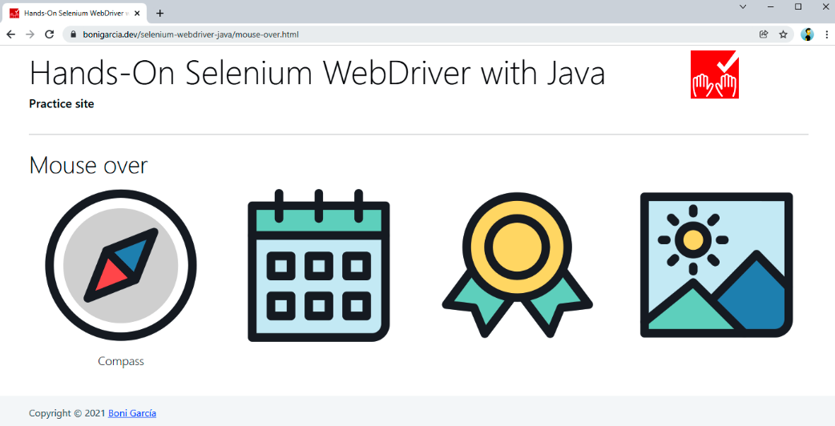
Figure 3-9. Practice web page with mouse-over images

Drag and Drop
Example 3-24 illustrates the use of drag and drop. This test uses the practice web shown in Figure 3-10.

Example 3-24. Test using drag and drop
@Test
void testDragAndDrop() {
driver.get("https://bonigarcia.dev/selenium-webdriver-java/drag-and-drop.html");
Actions actions = new Actions(driver);

WebElement draggable = driver.findElement(By.id("draggable"));
int offset = 100;
Point initLocation = draggable.getLocation();
actions.dragAndDropBy(draggable, offset, 0)
.dragAndDropBy(draggable, 0, offset)
.dragAndDropBy(draggable, -offset, 0)
.dragAndDropBy(draggable, 0, -offset).build().perform();
assertThat(initLocation).isEqualTo(draggable.getLocation());

WebElement target = driver.findElement(By.id("target"));
actions.dragAndDrop(draggable, target).build().perform();
assertThat(target.getLocation()).isEqualTo(draggable.getLocation());
}

We locate the draggable element.
We use dragAndDropBy() to move this element a fixed number of pixels (100) four times (right, bottom, left, and up).
We assert the element position is the same as the beginning.
We find a second element (not draggable this time).
We use dragAndDrop() to move the draggable element to the second one.
We assert the position of both elements is the same.

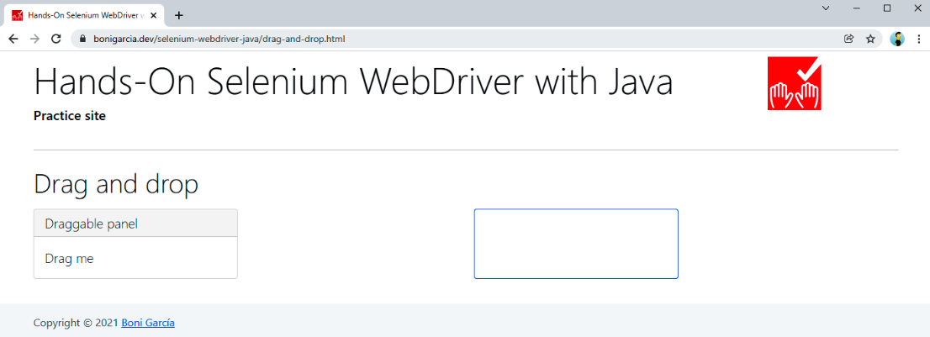
Figure 3-10. Practice web page with a draggable element

Click and Hold
The following example shows complex user gestures, including click and hold. To that aim, we practice with the web page in Figure 3-11.
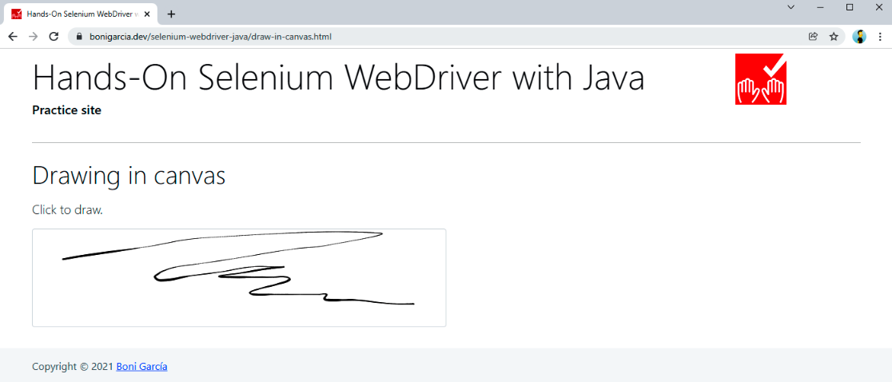
Figure 3-11. Practice web page with a drawable canvas
This page uses an open source JavaScript library called Signature Pad to draw signatures in HTML canvas using the mouse. Example 3-25 shows a test using it.

Example 3-25. Test drawing a circumference on a canvas
@Test
void testClickAndHold() {
driver.get("https://bonigarcia.dev/selenium-webdriver-java/draw-in-canvas.html");
Actions actions = new Actions(driver);

WebElement canvas = driver.findElement(By.tagName("canvas"));
actions.moveToElement(canvas).clickAndHold();

int numPoints = 10;
int radius = 30;
for (int i = 0; i <= numPoints; i++) {
double angle = Math.toRadians(360 * i / numPoints);
double x = Math.sin(angle) * radius;
double y = Math.cos(angle) * radius;
actions.moveByOffset((int) x, (int) y);
}
actions.release(canvas).build().perform();
}

We locate the canvas by tag name.
We move the mouse to this element with moveToElement() and then add the action clickAndHold() (for drawing into the canvas) to the actions pipeline.
We iterate using a fixed number of points, using the equation to find the points in a circumference.
We use the circumference points (x and y) to move the mouse by offset (moveByOffset()). Since the click is held from the previous step, the resulting compound action will move the mouse while the click button is pressed.
We release the click, build the action, and carry out the whole chain. As a result, a circumference should appear on the canvas.

Copy and Paste
This last example for user gestures automates a pervasive user action: copy and paste using the keyboard. Here, we use the web form available on the practice website. Example 3-26 shows a test impersonating copy and paste.

Example 3-26. Test impersonating copy and paste
@Test
void testCopyAndPaste() {
driver.get("https://bonigarcia.dev/selenium-webdriver-java/web-form.html");
Actions actions = new Actions(driver);

WebElement inputText = driver.findElement(By.name("my-text"));
WebElement textarea = driver.findElement(By.name("my-textarea"));

Keys modifier = SystemUtils.IS_OS_MAC ? Keys.COMMAND : Keys.CONTROL;
actions.sendKeys(inputText, "hello world").keyDown(modifier)
.sendKeys(inputText, "a").sendKeys(inputText, "c")
.sendKeys(textarea, "v").build().perform();

assertThat(inputText.getAttribute("value")).isEqualTo(textarea.getAttribute("value"));
}

We locate two web elements: an input text and a text area.
We use a modifier key for sending the combination Ctrl + C for copying (in Windows and Linux) or Cmd + C for copying (in macOS). To this aim, we use the class SystemUtils, available in the open source library Apache Commons IO (this dependency is used transitively in the Maven/Gradle project).
We implement the actions chain composed of the following steps:
- Send the char sequence hello world to the input text.
- Press the key modifier (Ctrl or Cmd, depending on the operating system). Remember that this key remains pressed until we explicitly release it.
- We send the key a to the input text. Since the modifier is active, the resulting combination is Ctrl + A (or Cmd + A), and as a result, all the text present in the input text is selected.
- We send the key c to the input text. Again, since the modifier is active, the combination is Ctrl + C (or Cmd + C), and the input text is copied to the clipboard.
- We send the key v to the text area. This means sending Ctrl + V (or Cmd + V), and the clipboard content is pasted to the text area.
We assert the content of both elements (input text and text area) is the same at the end of the text.

Waiting Strategies
Web applications are client-server distributed services in which the clients are the web browsers and the web servers are usually remote hosts. The intermediate network latency could affect the reliability of a WebDriver test. For instance, in the case of high-latency networks or overloaded servers, a slow response might negatively affect the expected conditions of WebDriver tests. In addition, modern web applications tend to be dynamic and asynchronous. Nowadays, JavaScript allows executing nonblocking (i.e., asynchronous) operations using different mechanisms, such as callbacks, promises, or async/await. In addition, we can retrieve data from other servers asynchronously, for example, using AJAX (Asynchronous JavaScript and XML) or REST (REpresentational State Transfer) services.
All in all, it is of paramount importance to have mechanisms pause and wait for certain conditions in our WebDriver tests. For this reason, the Selenium WebDriver API provides different waiting assets. The three principal waiting strategies are implicit, explicit, and fluent waits. The following subsections explain and show examples.
WARNING
For waiting in Java, you might think about including Thread.sleep() commands in your code. On the one hand, it is a simple solution, but on the other hand, it is considered a bad smell (i.e., a weak sign) that could lead to unreliable tests (since the delay conditions can change). As a general rule, I strongly discourage you from using it. Instead, consider using the aforementioned wait strategies.

Implicit Wait
The first waiting strategy provided by Selenium WebDriver is called implicit. This mechanism allows specifying an amount of time before throwing an exception when finding an element. By default, this wait has a value of zero seconds (i.e., it does not wait at all). But when we define an implicit wait value, Selenium WebDriver polls the DOM during the implicit wait value when trying to find an element. The poll time is specific to the driver implementation and is frequently less than five hundred ms. If the element is present in the elapsed time, the script continues. Otherwise, it throws an exception.
Example 3-27 illustrates this strategy. This test uses a practice page (see Figure 3-12) that dynamically loads several images into the DOM. Since these images are not available just before the page is loaded, we need to wait for these images to be available.
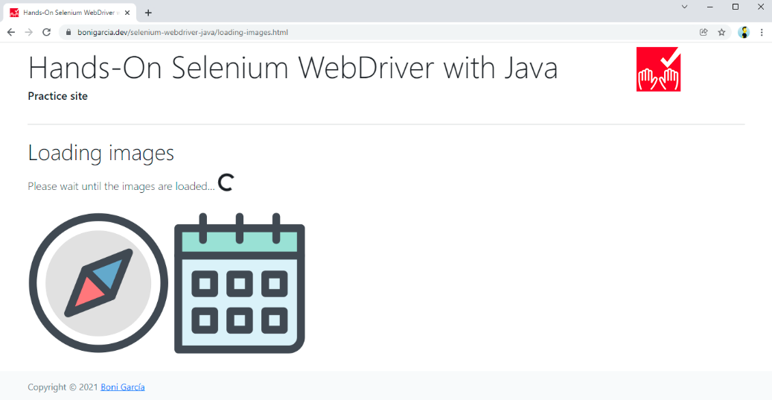
Figure 3-12. Practice web page loading images

Example 3-27. Test using an implicit wait in the “loading images” page
@Test
void testImplicitWait() {
driver.get("https://bonigarcia.dev/selenium-webdriver-java/loading-images.html");
driver.manage().timeouts().implicitlyWait(Duration.ofSeconds(10));

WebElement landscape = driver.findElement(By.id("landscape"));
assertThat(landscape.getAttribute("src")).containsIgnoringCase("landscape");
}

Before interacting with the elements, we specify an implicit wait strategy. In this case, we set up a timeout of 10 seconds.
In the following calls, we use the Selenium WebDriver API as usual.
TIP
You can play with this feature by dropping the implicit wait from the test (step 1). If you do that, you will notice that the test fails in step 2 due to a NoSuchElementException.
Although supported by the Selenium WebDriver API, implicit waits have different inconveniences you need to know. First, an implicit wait only works on finding elements. Second, we cannot customize its behavior since its implementation is driver-specific. Finally, and since implicit waits are applied globally, checking for the absence of web elements usually increases the execution time for the entire script. For these reasons, implicit waits are typically considered bad practice in most cases, and explicit and fluent waits are preferred instead.

Explicit Wait
The second waiting strategy, called explicit, allows pausing the test execution a maximum amount of time until a specific condition happens. To use this strategy, we need to create an instance of WebDriverWait, using the WebDriver object as the first constructor argument, and an instance of Duration as the second argument (to specify the timeout).
Selenium WebDriver provides a comprehensive set of expected conditions using the ExpectedConditions class. These conditions are very readable, and it does not require further explanation to understand their purpose. I recommend you use an autocomplete feature in your favorite IDE to discover all the possibilities. For example, Figure 3-13 shows this list in Eclipse.
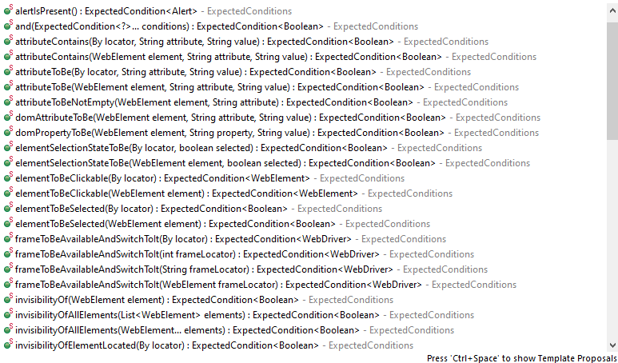
Figure 3-13. Autocomplete in Eclipse for the ExpectedConditions class
Example 3-28 shows a test using an explicit wait. In the example, we use the presenceofElementLocated condition to wait until one of the images is available on the practice web page.

Example 3-28. Test using an explicit wait in the “loading images” page
@Test
void testExplicitWait() {
driver.get("https://bonigarcia.dev/selenium-webdriver-java/loading-images.html");
WebDriverWait wait = new WebDriverWait(driver, Duration.ofSeconds(10));

WebElement landscape = wait.until(ExpectedConditions
.presenceOfElementLocated(By.id("landscape")));
assertThat(landscape.getAttribute("src")).containsIgnoringCase("landscape");
}
We create the wait instance. In this case, the selected timeout is 10 seconds.
We explicitly wait for a given condition (in this case, the presence of a given element) by invoking the until() method in the WebDriverWait object. To achieve a more readable statement, you can also statically import this expected condition (presenceOfElementLocated). In this book, I decided to keep the class name (ExpectedConditions) in these conditions to ease the autocomplete feature in IDEs as described before.
Example 3-29 shows another test using explicit waits. This test uses another practice web page called “slow calculator,” which contains a GUI of a basic calculator, tuned to wait a configurable time to get the result of basic arithmetic operations (by default, five seconds). Figure 3-14 shows a screenshot of this page.

Example 3-29. Test using an explicit wait in the “slow calculator” page
@Test
void testSlowCalculator() {
driver.get("https://bonigarcia.dev/selenium-webdriver-java/slow-calculator.html");

// 1 + 3
driver.findElement(By.xpath("//span[text()='1']")).click();
driver.findElement(By.xpath("//span[text()='+']")).click();
driver.findElement(By.xpath("//span[text()='3']")).click();
driver.findElement(By.xpath("//span[text()='=']")).click();

// ... should be 4, wait for it
WebDriverWait wait = new WebDriverWait(driver, Duration.ofSeconds(10));
wait.until(ExpectedConditions.textToBe(By.className("screen"), "4"));
}
We use XPath locators to click the buttons corresponding to operation 1 + 3.
Since the test should wait until the result is ready, we explicitly wait for that. In this case, the condition is the text of the element with a class name screen is equal to 4.
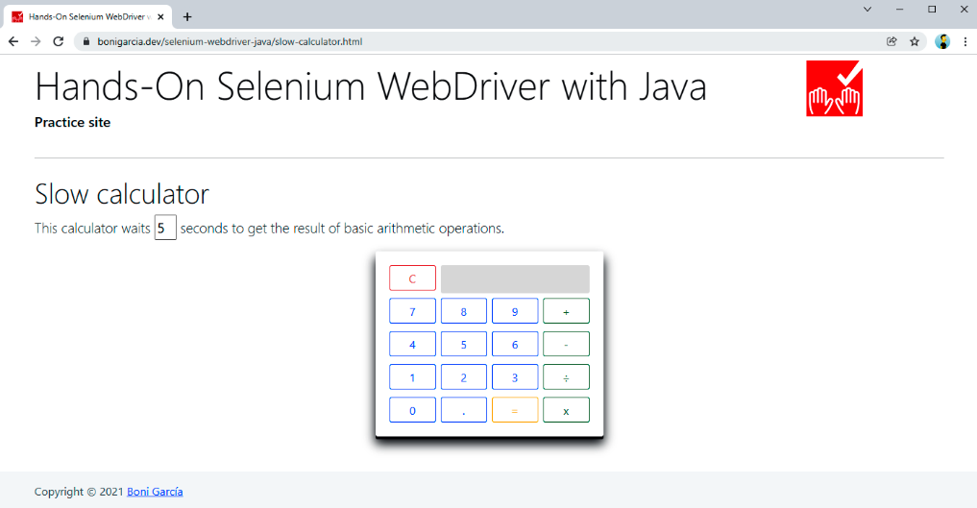
Figure 3-14. Practice web page with the “slow calculator” demo

Fluent Wait
The last strategy is a fluent wait. This mechanism is a generalization of explicit waits. In other words, we use fluent waits for pausing the test until certain conditions, but in addition, fluent waits provide fine-grained configuration capabilities. Table 3-12 summarizes the methods available in FluentWait. As its name suggests, this class provides a fluent API, and therefore, we can chain several invocations in the same line. Example 3-30 shows a test using fluent wait.
Method | Description
withTimeout(Duration timeout) | Timeout using Java Duration
pollingEvery(Duration interval) | How often the condition is evaluated (five hundred ms by default)
withMessage(String message)  withMessage(Supplier<String> messageSupplier) | Custom error message
ignoring(Class<? extends Throwable> exceptionType)  ignoring(Class<? extends Throwable> firstType,  Class<? extends Throwable> secondType)  ignoreAll(Collection<Class<? extends Throwable>> types) | Ignore specific exceptions while waiting for a condition
until(Function<? super T, V> isTrue) | Expected condition
Table 3-12. Fluent wait methods

Example 3-30. Test using a fluent wait
@Test
void testFluentWait() {
driver.get("https://bonigarcia.dev/selenium-webdriver-java/loading-images.html");
Wait<WebDriver> wait = new FluentWait<>(driver)
.withTimeout(Duration.ofSeconds(10))
.pollingEvery(Duration.ofSeconds(1))
.ignoring(NoSuchElementException.class);

WebElement landscape = wait.until(ExpectedConditions .presenceOfElementLocated(By.id("landscape")));
assertThat(landscape.getAttribute("src")).containsIgnoringCase("landscape");
}
As you can see, this test is very similar to Example 3-28, although using a FluentWait instance, we can specify additional characteristics. In this case, we change the poll time to one second.
TIP
The class WebDriverWait (presented in the previous subsection) extends the generic class FluentWait. Thus, you can use all the methods shown in Table 3-12 for explicit waits too.

RELATED FEATURES IN SELENIUM WEBDRIVER
In addition to the previously introduced waiting strategies, there are other complementary characteristics in Selenium WebDriver you should be aware of:
Loading strategies
Selenium WebDriver allows specifying different approaches for page loading. This feature is accessible through browser-specific capabilities (e.g., using ChromeOptions, FirefoxOptions, etc.). For this reason, I explain this feature in “Page Loading Strategies”.
Timeouts
Selenium WebDriver allows specifying the maximum elapsed time for page and script loading. I explain this feature in “Timeouts”.

Summary and Outlook
This chapter presented the foundations of the Selenium WebDriver API. First, you learned how to create and shut down WebDriver instances. These objects represent a browser controlled with Selenium WebDriver. This way, we use an instance of ChromeDriver for Chrome, FirefoxDriver for Firefox, etc. Second, you looked at Web​Ele⁠ment, a class representing different web page elements (e.g., links, images, form fields, etc.). Selenium WebDriver provides several strategies to locate web elements: by HTML attribute (id, name, or class), tag name, link text (complete or partial), CSS selector, and XPath. We also looked at a brand-new strategy of Selenium WebDriver 4 called relative locators. Then, we covered user actions’ impersonation, using the keyboard and the mouse. You can use these actions from simple actions (e.g., clicking a link, filling a text input, etc.) to complex user gestures (e.g., drag and drop, click and hover, etc.). Finally, we examined the ability to wait in Selenium WebDriver tests. This feature is critical due to the current distributed, dynamic, and asynchronous nature of web applications. There are three main wait strategies in Selenium WebDriver: implicit (specify a general timeout to wait for elements), explicit (pause test execution until a given condition), and fluent (extension of an explicit wait with some fine-grained setup).
The next chapter continues digging into the Selenium WebDriver API. In particular, Chapter 4 reviews those interoperable features in different browsers (Chrome, Edge, Firefox, etc.). Among these features, you will discover how to execute JavaScript, specify event listeners, configure timeouts for page and script loading, manage the browser history, make screenshots, manipulate cookies, manipulate dropdown lists (i.e., selects and data lists), handle window targets (i.e., tabs, frames, and iframes) and dialog boxes (i.e., alerts, prompts, confirmation, and modal pop-ups), use web storage, and understand the WebDriver exceptions.

